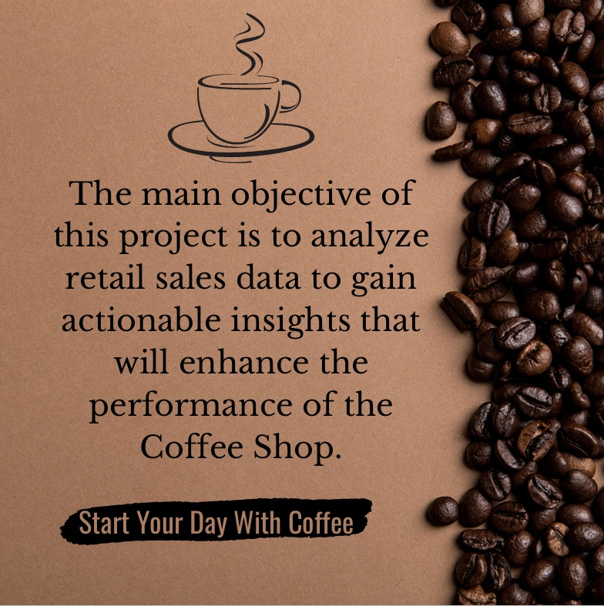

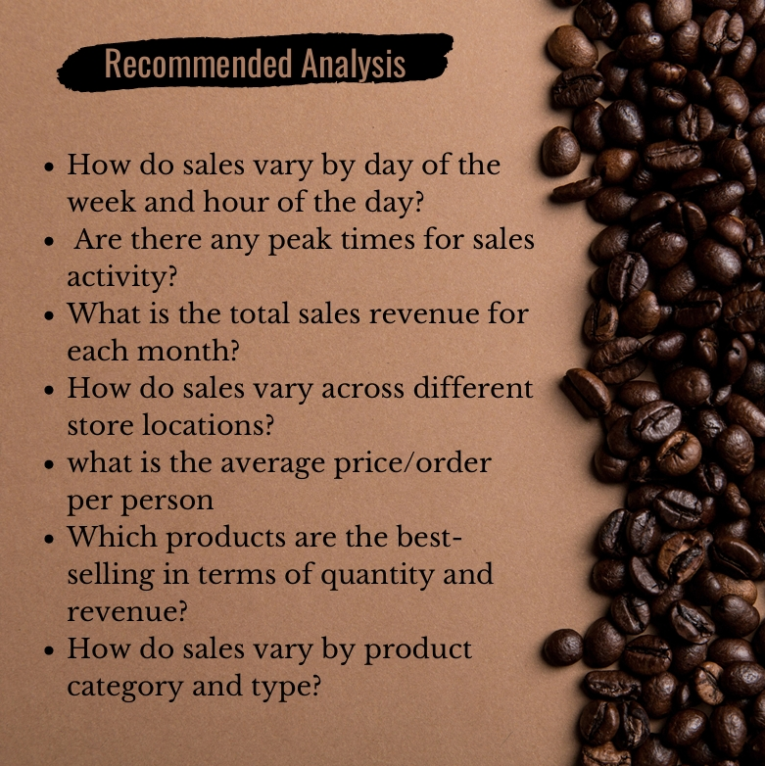

Sales varying by days

|  |  |
| --- | --- |
| **Row Labels** | **Sum of bill_price** |
| Sunday | $98,330.31 |
| Monday | $1,01,677.28 |
| Tuesday | $99,455.94 |
| Wednesday | $1,00,313.54 |
| Thursday | $1,00,767.78 |
| Friday | $1,01,373.00 |
| Saturday | $96,894.48 |
| **Grand Total** | **$6,98,812.33** |

Sales varying by hours

|  |  |
| --- | --- |
| **Row Labels** | **Sum of bill_price** |
| 6 | $21,900.27 |
| 7 | $63,526.47 |
| 8 | $82,699.87 |
| 9 | $85,169.53 |
| 10 | $88,673.39 |
| 11 | $46,319.14 |
| 12 | $40,192.79 |
| 13 | $40,367.45 |
| 14 | $41,304.74 |
| 15 | $41,733.10 |
| 16 | $41,122.75 |
| 17 | $40,134.31 |
| 18 | $34,286.20 |
| 19 | $28,446.68 |
| 20 | $2,935.64 |
| **Grand Total** | **$6,98,812.33** |

Peak Time of Sales

10am- 11am

Total Sales revenue per month

|  |  |
| --- | --- |
| **Row Labels** | **Sum of bill_price** |
| January | $81,677.74 |
| February | $76,145.19 |
| March | $98,834.68 |
| April | $1,18,941.08 |
| May | $1,56,727.76 |
| June | $1,66,485.88 |
| **Grand Total** | **$6,98,812.33** |

Sales across various location

|  |  |
| --- | --- |
| **Row Labels** | **Sum of bill_price** |
| Astoria | $2,32,243.91 |
| Hell's Kitchen | $2,36,511.17 |
| Lower Manhattan | $2,30,057.25 |
| **Grand Total** | **$6,98,812.33** |

Average price per person

4.69

Average Order Per Person

1.438276241

Best selling product

Barista Espresso

Sales varying by product category and types

|  |  |
| --- | --- |
| **Row Labels** | **Sum of bill_price** |
| **Bakery** |  |
| Biscotti | $19,793.53 |
| Pastry | $25,655.99 |
| Scone | $36,866.12 |
| **Branded** |  |
| Clothing | $6,163.00 |
| Housewares | $7,444.00 |
| **Coffee** |  |
| Barista Espresso | $91,406.20 |
| Drip coffee | $31,984.00 |
| Gourmet brewed coffee | $70,034.60 |
| Organic brewed coffee | $37,746.50 |
| Premium brewed coffee | $38,781.15 |
| **Coffee beans** |  |
| Espresso Beans | $5,560.25 |
| Gourmet Beans | $6,798.00 |
| Green beans | $1,340.00 |
| House blend Beans | $3,294.00 |
| Organic Beans | $8,509.50 |
| Premium Beans | $14,583.50 |
| **Drinking Chocolate** |  |
| Hot chocolate | $72,416.00 |
| **Flavours** |  |
| Regular syrup | $6,084.80 |
| Sugar free syrup | $2,324.00 |
| **Loose Tea** |  |
| Black tea | $2,711.85 |
| Chai tea | $4,301.25 |
| Green tea | $1,470.75 |
| Herbal tea | $2,729.75 |
| **Packaged Chocolate** |  |
| Drinking Chocolate | $2,728.04 |
| Organic Chocolate | $1,679.60 |
| **Tea** |  |
| Brewed Black tea | $47,932.00 |
| Brewed Chai tea | $77,081.95 |
| Brewed Green tea | $23,852.50 |
| Brewed herbal tea | $47,539.50 |
| **Grand Total** | **$6,98,812.33** |